 |  |  |  |  |  |  |  |  |  |  |  |  |  |  |  |  | Return Order Date: |  |  |  |  |  | Delivery Date:
 |  |  |  |  |  |  |  |  |  |  |  |  |  |  |  |  | 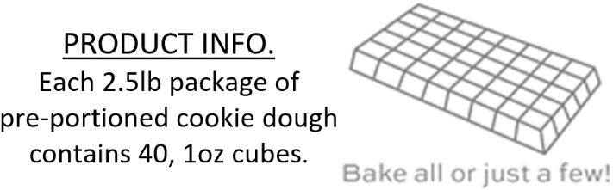
My Name: |  |  |  |  |  |  |  |  |  | My Phone: |  |  |  |  |  |  | Chocolate Chip | Confetti Cookie Dough |  | Oatmeal Cranberry White Chunk | Peanut Butter | Snickerdoodle |  | Triple Chocolate | White Chunk Macadamia Nut | ALLERGEN NOTICE:  All products contain Egg, Wheat. *Candy, Oat. Cran., & Mac Nut contain Milk. *Candy, Choc. Chip, Oat. Cran., & Mac Nut contain Soy. *Peanut Butter contains Peanut. *Mac Nut contains Macadamia Nuts. These products are manufactured in a facility and on equipment which processes nut products.
Organization: |  |  |  |  |  |  |  |  | Checks Payable:
Contact Name: |  |  |  |  |  |  |  |  |  | Contact Phone:
 |  |  |  |  |  | Please collect payment when taking orders.
MY GOAL  GROUP GOAL  FUNDRAISER PURPOSE |  |  |  |  | Customer Name |  |  |  |  |  |  | Phone |  |  |  |  | $17 | $17 |  | $17 | $17 | $17 |  | $17 | $17 | Items | Amount
 |  |  |  |  | 1 |  |  |  |  |  |  |  |  |  |  |  |  |  |  |  |  |  |  |  |  |  | $
 |  |  |  |  | 2 |  |  |  |  |  |  |  |  |  |  |  |  |  |  |  |  |  |  |  |  |  | $
 |  |  |  |  | 3 |  |  |  |  |  |  |  |  |  |  |  |  |  |  |  |  |  |  |  |  |  | $
 |  |  |  |  | 4 |  |  |  |  |  |  |  |  |  |  |  |  |  |  |  |  |  |  |  |  |  | $
 |  |  |  |  | 5 |  |  |  |  |  |  |  |  |  |  |  |  |  |  |  |  |  |  |  |  |  | $
 |  |  |  |  | 6 |  |  |  |  |  |  |  |  |  |  |  |  |  |  |  |  |  |  |  |  |  | $
 |  |  |  |  | 7 |  |  |  |  |  |  |  |  |  |  |  |  |  |  |  |  |  |  |  |  |  | $
 |  |  |  |  | 8 |  |  |  |  |  |  |  |  |  |  |  |  |  |  |  |  |  |  |  |  |  | $
 |  |  |  |  | 9 |  |  |  |  |  |  |  |  |  |  |  |  |  |  |  |  |  |  |  |  |  | $
 |  |  |  |  | 10 |  |  |  |  |  |  |  |  |  |  |  |  |  |  |  |  |  |  |  |  |  | $
Scan QR to go to  the online store. |  |  |  |  | 11 |  |  |  |  |  |  |  |  |  |  |  |  |  |  |  |  |  |  |  |  |  | $
 |  |  |  |  | 12 |  |  |  |  |  |  |  |  |  |  |  |  |  |  |  |  |  |  |  |  |  | $
 |  |  |  |  | 13 |  |  |  |  |  |  |  |  |  |  |  |  |  |  |  |  |  |  |  |  |  | $
 |  |  |  |  | 14 |  |  |  |  |  |  |  |  |  |  |  |  |  |  |  |  |  |  |  |  |  | $
 |  |  |  |  | 15 |  |  |  |  |  |  |  |  |  |  |  |  |  |  |  |  |  |  |  |  |  | $
 |  |  |  |  | 16 |  |  |  |  |  |  |  |  |  |  |  |  |  |  |  |  |  |  |  |  |  | $
 |  |  |  |  | 17 |  |  |  |  |  |  |  |  |  |  |  |  |  |  |  |  |  |  |  |  |  | $
 |  |  |  |  | 18 |  |  |  |  |  |  |  |  |  |  |  |  |  |  |  |  |  |  |  |  |  | $
 |  |  |  |  | 19 |  |  |  |  |  |  |  |  |  |  |  |  |  |  |  |  |  |  |  |  |  | $
Legacy Fundraising Partners  9195231605 |  |  |  |  |  |  | www.legacy-fundraising.com |  |  |  |  |  |  |  |  |  | CC | CF |  | OC | PB | SN |  | TC | MN | Items | Amount
 |  |  |  |  |  |  | www.butterbraid.com |  |  |  |  |  |  |  | Please Total:

